

GOVERNMENT OF INDIA

**MINISTRY OF SKILL DEVELOPMENT & ENTREPRENEURSHIP**

DIRECTORATE GENERAL OF TRAINING

**NATIONAL SKILL TRAINING INSTITUTE**

Address: CP-16, CP Block, Sector V, Salt Lake City,

Kolkata-700091, West Bengal.

**CERTIFICATE**

This is to certify that following trainees have completed their project titled

**“NSTI Smart Cloud Campus For IBM Program – IT, Networking and Cloud (Technical Diploma)**

|  |  |
| --- | --- |
| **ROLL NO** | **NAME** |
| ADIT19AU03269 | RUPAMA MAJEE |

|  |  |  |
| --- | --- | --- |
| Miss.Arpita Roy | Mr.K.l.kuli Mr.G.C.Ramamurthy | Mr.Sarbojit Neogi |
| IBM Faculty | Director Head of office/Principal | Section In-charge |

**ACKNOWLEDGEMENT**

We would like to express my sincere gratitude to several individuals and organizations for supporting me throughout my diploma study. First, I wish to express my sincere gratitude to my trainer, Miss Arpita Roy for his enthusiasm, patience, insightful comments, helpful information, practical advice and unceasing ideas that have helped me tremendously at all times in my study and writing of this project report. His immense knowledge, profound experience and professional expertise in computer science has enabled me to complete this project successfully.

I also wish to express my sincere thanks to the National Skill Training Institute(W) Saltlake,Kolkata for accepting me into the diploma program. In addition, I am deeply indebted to the Ministry of Skill Development & Entrepreneurship and IBM for granting me the diploma course. This technical and financial support has enabled me to complete my diploma course studies successfully. Also, I am grateful the Miss. Arpita Roy faculty of NSTI (W)Saltlake for supporting me for course completion in the specific subject.

I am also grateful to the following NSTI Regional Director Sir Mr. K.L. Kuli and Principal of NSTI (W) Saltlake G.C. Ramamurti & Section in charge Mr .Sarbojit Neogi for their consistent support and assistance.

**ABSTRACT**

This application is developed using NodeJS and the Express framework, when. Fortunately, this task is easy to accomplish using the Mongoose package for JavaScript. In this project I’ll show you how to create an application using NodeJS, Express .

**INDEX**

|  |  |  |
| --- | --- | --- |
| **Sr. No.** | **Table of Contents** | **Page No.** |
| 1 | Chapter 1: Introduction | 5-10 |
| 2 | Chapter 2: Services and Tools Required | 11-15 |
| 3 | Chapter 3: Project Architecture | 16-17 |
| 4 | Chapter 4: Architecture Blocks Detail Working | 18 |
| 5 | Conclusion | 19 |
| 6 | References | 20 |
| 7 | Code | 21-25 |

**CHAPTER 1**

**INTRODUCTION**

JavaServer Pages (JSP) is a Java standard technology that enables you to write dynamic, data-driven pages for your Java web applications.The two technologies typically work together, especially in older Java web applications. From a coding perspective, the most obvious difference between them is that with servlets you write Java code and then embed client-side markup (like HTML) into that code, whereas with JSP you start with the client-side script or markup, then embed JSP tags to connect your page to the Java backend.

JSP is also closely related to JSF, a Java specification for building MVC (model-view-controller) web applications. JSP is a relatively simpler and older technology than JSF, which is the standard for Java web frameworks like [Eclipse Mojarra](https://javaserverfaces.github.io/), MyFaces, and PrimeFaces. While it is not uncommon to see JSP used as the frontend for older JSF applications, [Facelets](https://javaee.github.io/tutorial/jsf-facelets.html) is the preferred view technology for modern JSF implementations.

* 1. **Overview**

This was done to get us ready for whatever facet we chose. A major part of this project is to show what we have learned and put it into practice.

* 1. **Feature**

•Asynchronous and Event Driven − All APIs of Node.js library are asynchronous, that is, non-blocking. It essentially means a Node.js based server never waits for an API to return data. The server moves to the next API after calling it and a notification mechanism of Events of Node.js helps the server to get a response from the previous API call.

•Very Fast − Being built on Google Chrome's V8 JavaScript Engine, Node.js library is very fast in code execution.

•Single Threaded but Highly Scalable − Node.js uses a single threaded model with event looping. Event mechanism helps the server to respond in a non-blocking way and makes the server highly scalable as opposed to traditional servers which create limited threads to handle requests. Node.js uses a single threaded program and the same program can provide service to a much larger number of requests than traditional servers like Apache HTTP Server.

•No Buffering − Node.js applications never buffer any data. These applications simply output the data in chunks.

•License − Node.js is released under the MIT license.

* 1. **Advantages**
* Easy to learn. Node. ...
* Keeping things simple. Before the product launch startupers wear many hats and face many challenges. ...
* Faster time-to-market. Time is priceless for startupers. ...
* Scalability. ...
* Battle-tested old hand. ...
* MVP development. ...
* Community.
  1. **Future Work**

The purpose of this document is to describe the functionality and specifications of the design of a web application and to learn how to build a simple web-based application using Node Js and Mongo DB.

* 1. **Scope**

Node. js is an open-source, cross-platform server environment, and it enables users to run javascript on the server. JavaScript users can make use of the Node. js environment to deploy the language for scripting on the server-side, while also running scripts to generate the dynamic web page content. The scope is the binding part between the HTML (view) and the JavaScript (controller). The scope is an object with the available properties and methods. The scope is available for both the view and the controller. You have more detailed explanation here. The scope of a variable are the locations where it is accessible. For example: ... Browsers and Node.js have global variables for referring to the global object.

**CHAPTER 2**

**SERVICES AND TOOLS REQUIRED**

**2.1 Services Used**

**2.1.1 Liberty Profile**

Liberty Profile is part of IBM WebSphere Application Server V8. ... It is very lightweight profile of WebSphere Application Server. Liberty profile is a flexible and dynamic profile of WAS which enables the WAS server to deploy only required custom features instead of deploying a big set of available JEE components.

**2.2 Tools and Softwares used**

**2.2.1 NodeJS**

# **What is Node.js?**

Node.js is an open-source server side runtime environment built on Chrome's V8 JavaScript engine. It provides an event driven, non-blocking (asynchronous) I/O and cross-platform runtime environment for building highly scalable server-side application using JavaScript.

Node.js can be used to build different types of applications such as command line application, web application, real-time chat application, REST API server etc. However, it is mainly used to build network programs like web servers, similar to PHP, Java, or ASP.NET.

Node.js was written and introduced by Ryan Dahl in 2009.

**Advantages of Node.js**

1. Node.js is an open-source framework under MIT license. (MIT license is a free software license originating at the Massachusetts Institute of Technology (MIT).)
2. Uses JavaScript to build entire server side application.
3. Lightweight framework that includes bare minimum modules. Other modules can be included as per the need of an application.
4. Asynchronous by default. So it performs faster than other frameworks.
5. Cross-platform framework that runs on Windows, MAC or Linux

**2.2.2 HTML**

# **What is HTML**

HTML is an acronym which stands for **Hyper Text Markup Language** which is used for creating web pages and web applications. Let's see what is meant by Hypertext Markup Language, and Web page.

**Hyper Text:** HyperText simply means "Text within Text." A text has a link within it, is a hypertext. Whenever you click on a link which brings you to a new webpage, you have clicked on a hypertext. HyperText is a way to link two or more web pages (HTML documents) with each other.

**Markup language:** A markup language is a computer language that is used to apply layout and formatting conventions to a text document. Markup language makes text more interactive and dynamic. It can turn text into images, tables, links, etc.

**Web Page:** A web page is a document which is commonly written in HTML and translated by a web browser. A web page can be identified by entering an URL. A Web page can be of the static or dynamic type. **With the help of HTML only, we can create static web pages**.

Hence, HTML is a markup language which is used for creating attractive web pages with the help of styling, and which looks in a nice format on a web browser. An HTML document is made of many HTML tags and each HTML tag contains different content.

## Features of HTML

1) It is a very **easy and simple language**. It can be easily understood and modified.

2) It is very easy to make an **effective presentation** with HTML because it has a lot of formatting tags.

3) It is a **markup language**, so it provides a flexible way to design web pages along with the text.

4) It facilitates programmers to add a **link** on the web pages (by html anchor tag), so it enhances the interest of browsing of the user.

5) It is **platform-independent** because it can be displayed on any platform like Windows, Linux, and Macintosh, etc.

6) It facilitates the programmer to add **Graphics, Videos, and Sound** to the web pages which makes it more attractive and interactive.

7) HTML is a case-insensitive language, which means we can use tags either in lower-case or upper-case.

**2.2.3 Cloud Foundry**

Cloud platforms let anyone deploy network apps or services and make them available to the world in a few minutes. When an app becomes popular, the cloud scales it to handle more traffic, replacing build-out and migration efforts that once took months with a few keystrokes. Cloud platforms enable you to focus exclusively on your apps and data without worrying about underlying infrastructure.

The following diagram shows the layers of a typical technology stack, and compares the traditional IT model to the cloud platform model:

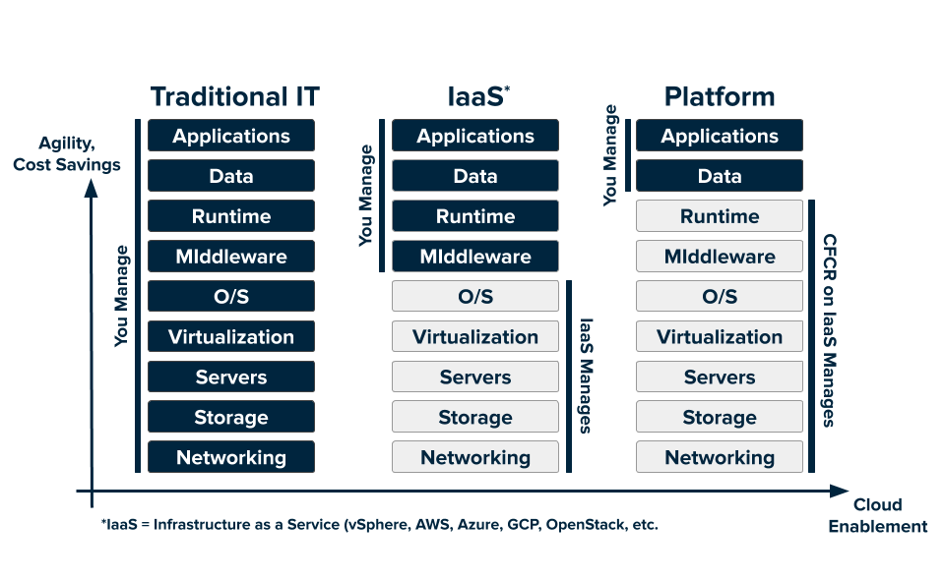

What are the key benefits of Cloud Foundry?

* Application portability.
* Application auto-scaling.
* Centralized platform administration.
* Centralized logging.
* Dynamic routing.
* Application health management.
* Integration with external logging components like Elasticsearch and Logstash.
* Role-based access for deployed applications.
* Provision for vertical and horizontal scaling.
* Infrastructure security.
* Support for various IaaS providers.

**CHAPTER 3**

**PROJECT ARCHITECTURE**

**3.1 Architecture**

**Node**. **Js** uses the “Single Threaded Event Loop” **architecture** to handle multiple concurrent clients. **Node**. **Js** Processing Model is based on the JavaScript event-based model along with the JavaScript callback mechanism.

**USER FRONTEND BACKEND**

|  |  |  |
| --- | --- | --- |
| **UserInternet** | Web design**HTML 5** | Node.js JavaScript npm Computer Icons Web application, text, logo png |  PNGEgg**NODEJS 14.0** |

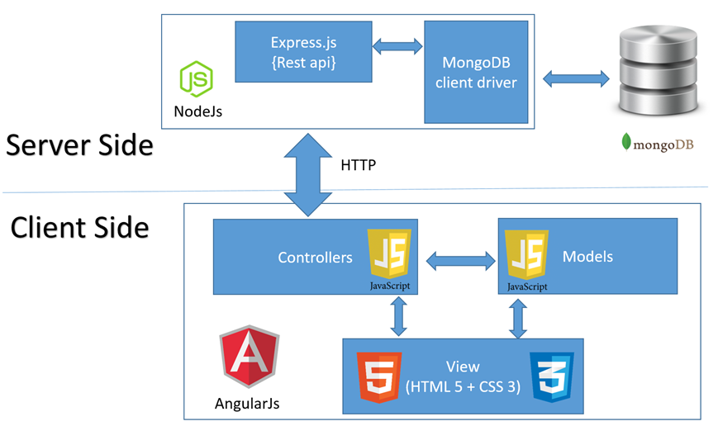

**CHAPTER 4**

**ARCHITECTURE BLOCKS DETAIL WORKING**

**NodeJS**

# **What is Node.js?**

Node.js is an open-source server side runtime environment built on Chrome's V8 JavaScript engine. It provides an event driven, non-blocking (asynchronous) I/O and cross-platform runtime environment for building highly scalable server-side application using JavaScript.

Node.js can be used to build different types of applications such as command line application, web application, real-time chat application, REST API server etc. However, it is mainly used to build network programs like web servers, similar to PHP, Java, or ASP.NET.

Node.js was written and introduced by Ryan Dahl in 2009.

**Advantages of Node.js**

1.Node.js is an open-source framework under MIT license. (MIT license is a free software license originating at the Massachusetts Institute of Technology (MIT).)

2.Uses JavaScript to build entire server side application.

3.Lightweight framework that includes bare minimum modules. Other modules can be included as per the need of an application.

4.Asynchronous by default. So it performs faster than other frameworks.

5.Cross-platform framework that runs on Windows, MAC or Linux

**HTML**

# **What is HTML**

HTML is an acronym which stands for **Hyper Text Markup Language** which is used for creating web pages and web applications. Let's see what is meant by Hypertext Markup Language, and Web page.

**Hyper Text:** HyperText simply means "Text within Text." A text has a link within it, is a hypertext. Whenever you click on a link which brings you to a new webpage, you have clicked on a hypertext. HyperText is a way to link two or more web pages (HTML documents) with each other.

**Markup language:** A markup language is a computer language that is used to apply layout and formatting conventions to a text document. Markup language makes text more interactive and dynamic. It can turn text into images, tables, links, etc.

**Web Page:** A web page is a document which is commonly written in HTML and translated by a web browser. A web page can be identified by entering an URL. A Web page can be of the static or dynamic type. **With the help of HTML only, we can create static web pages**.

Hence, HTML is a markup language which is used for creating attractive web pages with the help of styling, and which looks in a nice format on a web browser. An HTML document is made of many HTML tags and each HTML tag contains different content.

## Features of HTML

1) It is a very **easy and simple language**. It can be easily understood and modified.

2) It is very easy to make an **effective presentation** with HTML because it has a lot of formatting tags.

3) It is a **markup language**, so it provides a flexible way to design web pages along with the text.

4) It facilitates programmers to add a **link** on the web pages (by html anchor tag), so it enhances the interest of browsing of the user.

5) It is **platform-independent** because it can be displayed on any platform like Windows, Linux, and Macintosh, etc.

6) It facilitates the programmer to add **Graphics, Videos, and Sound** to the web pages which makes it more attractive and interactive.

7) HTML is a case-insensitive language, which means we can use tags either in lower-case or upper-case.

**Cloud Foundry**

Cloud platforms let anyone deploy network apps or services and make them available to the world in a few minutes. When an app becomes popular, the cloud scales it to handle more traffic, replacing build-out and migration efforts that once took months with a few keystrokes. Cloud platforms enable you to focus exclusively on your apps and data without worrying about underlying infrastructure.

The following diagram shows the layers of a typical technology stack, and compares the traditional IT model to the cloud platform model:



**What are the key benefits of Cloud Foundry?**

* Application portability.
* Application auto-scaling.
* Centralized platform administration.
* Centralized logging.
* Dynamic routing.
* Application health management.
* Integration with external logging components like Elasticsearch and Logstash.
* Role-based access for deployed applications.
* Provision for vertical and horizontal scaling.
* Infrastructure security.
* Support for various IaaS providers.

**CHAPTER 5**

**PROJECT BUDGET**

|  |  |  |  |
| --- | --- | --- | --- |
| **Sr. No** | **Cloud Services and Coding Cost** | **Single Price (Rs)** | **Total** |
|  |  | N/A |  |
|  |  |  |  |
|  |  |  |  |
|  |  |  |  |
|  |  |  |  |
|  |  |  |  |
|  |  |  |  |
|  |  |  |  |
|  |  |  |  |
|  |  |  |  |
|  |  |  |  |
|  |  |  |  |
|  |  |  |  |
| Total | | |  |

**CONCLUSION**

While building an application using NodeJS, Express it’s important to make sure everything I need is installed and configured correctly. In this project, I have covered those key steps in the process, and we also walked through the code needed to make the application work.

**REFERENCES**

Websites:

• [www.w3schools.com](http://www.w3schools.com)

• [www.tutorialspoint.com](http://www.tutorialspoint.com)

• [www.youtube.com](http://www.youtube.com)

• [www.github.com](http://www.github.com)

• www.nodejs.org

**CODE**

**Index.html**

<!DOCTYPE html>

<html>

<title>W3.CSS Template</title>

<meta charset="UTF-8">

<meta name="viewport" content="width=device-width, initial-scale=1">

<link rel="stylesheet" href="https://www.w3schools.com/w3css/4/w3.css">

<style>

body {font-family: "Times New Roman", Georgia, Serif;}

h1, h2, h3, h4, h5, h6 {

font-family: "Playfair Display";

letter-spacing: 5px;

}

</style>

<body>

<!-- Navbar (sit on top) -->

<div class="w3-top">

<div class="w3-bar w3-white w3-padding w3-card" style="letter-spacing:4px;">

<a href="#home" class="w3-bar-item w3-button">Gourmet au Catering</a>

<!-- Right-sided navbar links. Hide them on small screens -->

<div class="w3-right w3-hide-small">

<a href="#about" class="w3-bar-item w3-button">About</a>

<a href="#menu" class="w3-bar-item w3-button">Menu</a>

<a href="#contact" class="w3-bar-item w3-button">Contact</a>

</div>

</div>

</div>

<!-- Header -->

<header class="w3-display-container w3-content w3-wide" style="max-width:1600px;min-width:500px" id="home">

<img class="w3-image" src="hamburger.jpg" alt="Hamburger Catering" width="1600" height="800">

<div class="w3-display-bottomleft w3-padding-large w3-opacity">

<h1 class="w3-xxlarge">Le Catering</h1>

</div>

</header>

<!-- Page content -->

<div class="w3-content" style="max-width:1100px">

<!-- About Section -->

<div class="w3-row w3-padding-64" id="about">

<div class="w3-col m6 w3-padding-large w3-hide-small"></div>

<img src="tablesetting2.jpg" class="w3-round w3-image w3-opacity-min" alt="Table Setting" width="600" height="750">

</div>

<div class="w3-col m6 w3-padding-large">

<h1 class="w3-center">About Catering</h1><br>

<h5 class="w3-center">Tradition since 1889</h5>

<p class="w3-large">The Catering was founded in blabla by Mr. Smith in lorem ipsum dolor sit amet, consectetur adipiscing elit consectetur adipiscing elit, sed do eiusmod tempor incididunt ut labore et dolore magna aliqua. Ut enim ad minim veniam, quis nostrud exercitation ullamco laboris nisi ut aliquip ex ea commodo consequat. Duis aute iruredolor in reprehenderit in voluptate velit esse cillum dolore eu fugiat nulla pariatur.We only use <span class="w3-tag w3-light-grey">seasonal</span> ingredients.</p>

<p class="w3-large w3-text-grey w3-hide-medium">Excepteur sint occaecat cupidatat non proident, sunt in culpa qui officia deserunt mollit anim id est laborum consectetur adipiscing elit, sed do eiusmod temporincididunt ut labore et dolore magna aliqua. Ut enim ad minim veniam, quis nostrud exercitation ullamco laboris nisi ut aliquip ex ea commodo consequat.</p>

</div>

</div>

<hr>

<!-- Menu Section -->

<div class="w3-row w3-padding-64" id="menu">

<div class="w3-col l6 w3-padding-large">

<h1 class="w3-center">Our Menu</h1><br>

<h4>Bread Basket</h4>

<p class="w3-text-grey">Assortment of fresh baked fruit breads and muffins 5.50</p><br>

<h4>Honey Almond Granola with Fruits</h4>

<p class="w3-text-grey">Natural cereal of honey toasted oats, raisins, almonds and dates 7.00</p><br>

<h4>Belgian Waffle</h4>

<p class="w3-text-grey">Vanilla flavored batter with malted flour 7.50</p><br>

<h4>Scrambled eggs</h4>

<p class="w3-text-grey">Scrambled eggs, roasted red pepper and garlic, with green onions 7.50</p><br>

<h4>Blueberry Pancakes</h4>

<p class="w3-text-grey">With syrup, butter and lots of berries 8.50</p>

</div>

<div class="w3-col l6 w3-padding-large">

<img src="tablesetting.jpg" class="w3-round w3-image w3-opacity-min" alt="Menu" style="width:100%">

</div>

</div>

<hr>

<!-- Contact Section -->

<div class="w3-container w3-padding-64" id="contact">

<h1>Contact</h1><br>

<p>We offer full-service catering for any event, large or small. We understand your needs and we will cater the food to satisfy the biggerst criteria of them all, both look and taste. Do not hesitate to contact us.</p>

<p class="w3-text-blue-grey w3-large"><b>Catering Service, 42nd Living St, 43043 New York, NY</b></p>

<p>You can also contact us by phone 00553123-2323 or email catering@catering.com, or you can send us a message here:</p>

<form action="/action_page.php" target="_blank">

<p><input class="w3-input w3-padding-16" type="text" placeholder="Name" required name="Name"></p>

<p><input class="w3-input w3-padding-16" type="number" placeholder="How many people" required name="People"></p>

<p><input class="w3-input w3-padding-16" type="datetime-local" placeholder="Date and time" required name="date" value="2020-11-16T20:00"></p>

<p><input class="w3-input w3-padding-16" type="text" placeholder="Message \ Special requirements" required name="Message"></p>

<p><button class="w3-button w3-light-grey w3-section" type="submit">SEND MESSAGE</button></p>

</form>

</div>

<!-- End page content -->

</div>

<!-- Footer -->

<footer class="w3-center w3-light-grey w3-padding-32">

<p>Powered by <a href="https://www.w3schools.com/w3css/default.asp" title="W3.CSS" target="_blank" class="w3-hover-text-green">w3.css</a></p>

</footer>

</body>

</html>

**App.js**

var express = require('express');

var app = express();

var path = require('path');

app.use(express.static('public'));

app.use('/images',express.static(__dirname + '/images'));

// viewed at http://localhost:8080

app.get('/', function(req, res) {

res.sendFile(path.join(__dirname + '/index.html'));

});

{/* <button onclick="myFunction()">Click Me!</button> */}

app.listen(8080);

This is home page

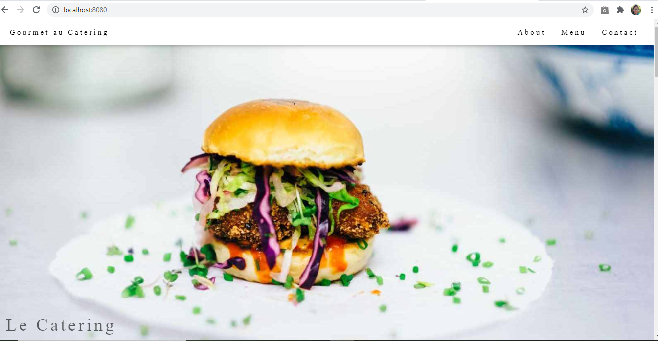

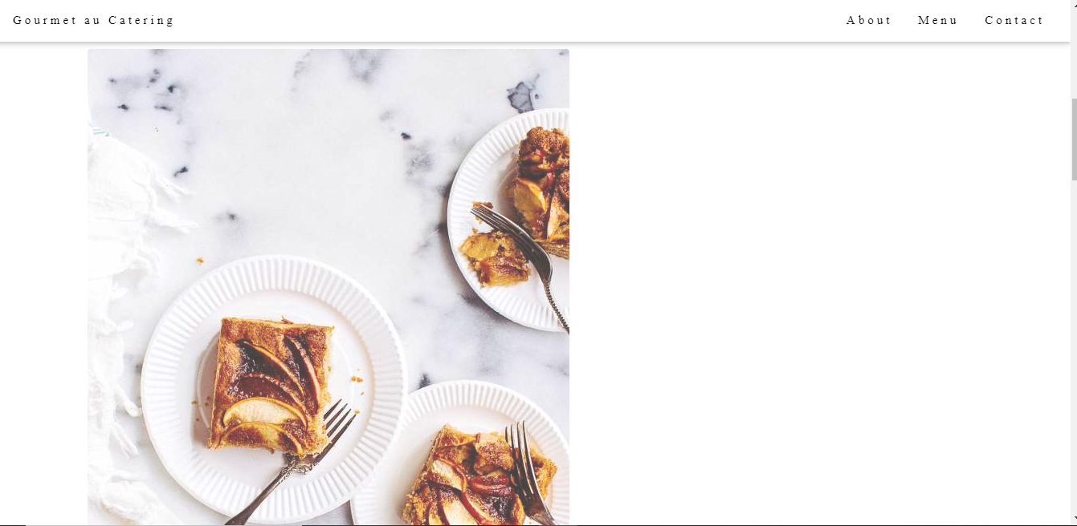

This is about page

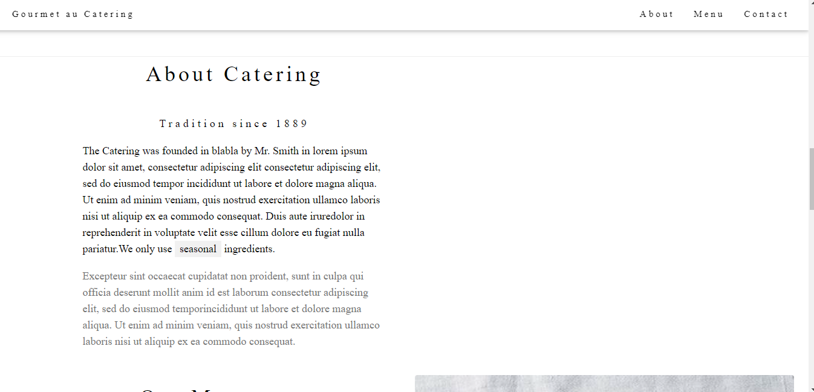

This is Menu page

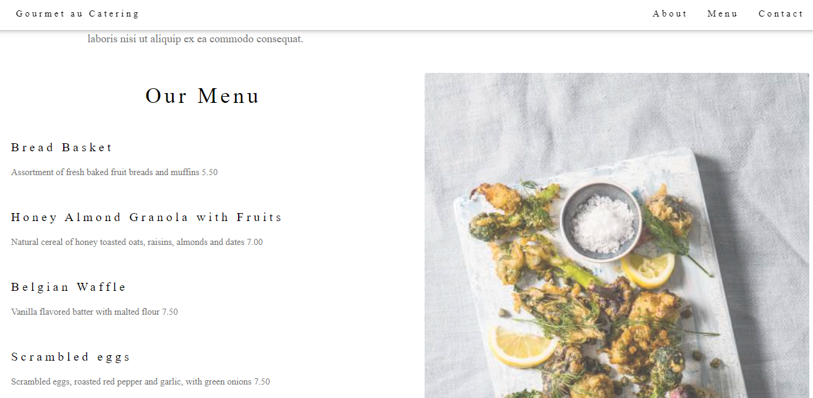

This is contact page

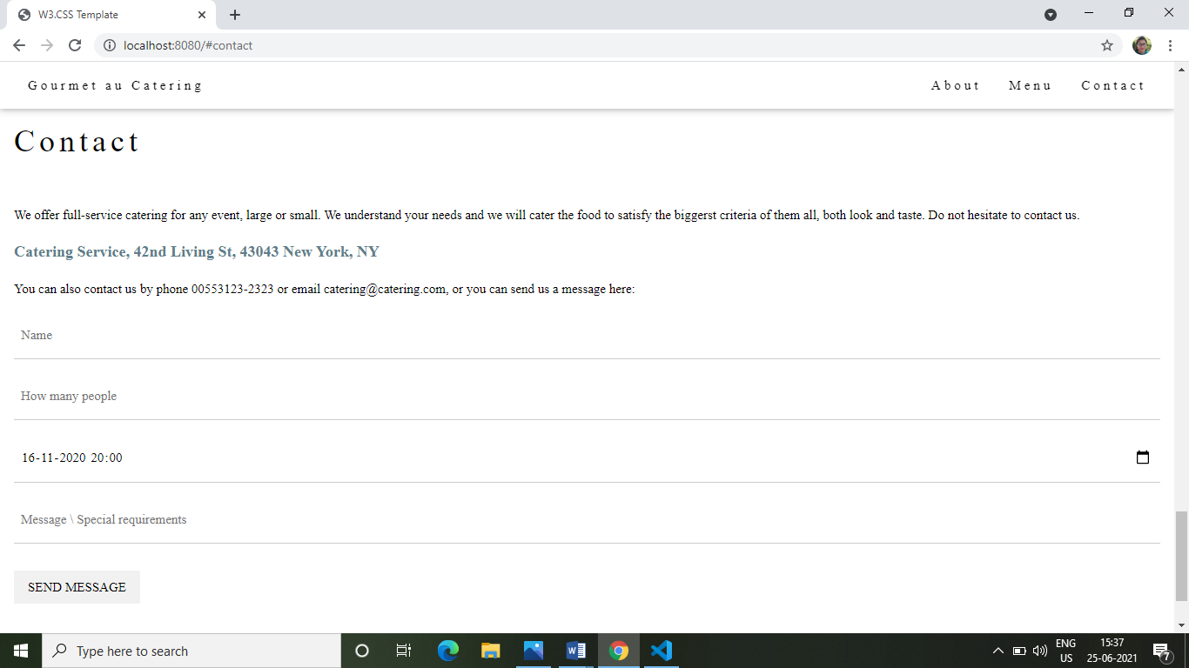

THANK YOU